**Generating ER Diagram in Oracle SQL Developer**

**(Documented by using – Oracle SQL Developer Version 4.0.1.14)**

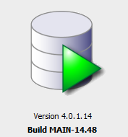

**Step 1:**

1. Open Oracle SQL Developer

**Step 2:**

2. Click **File → Data Modeler → Import → Data Dictionary**

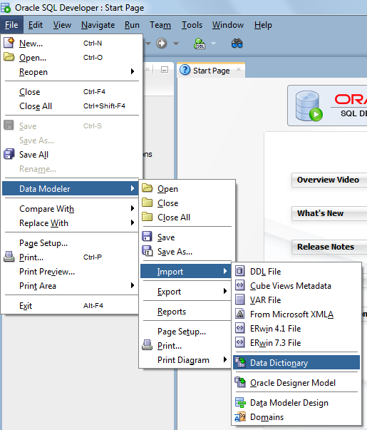

**Step 3:**

In the dialog box Select database connection to connect to desired database

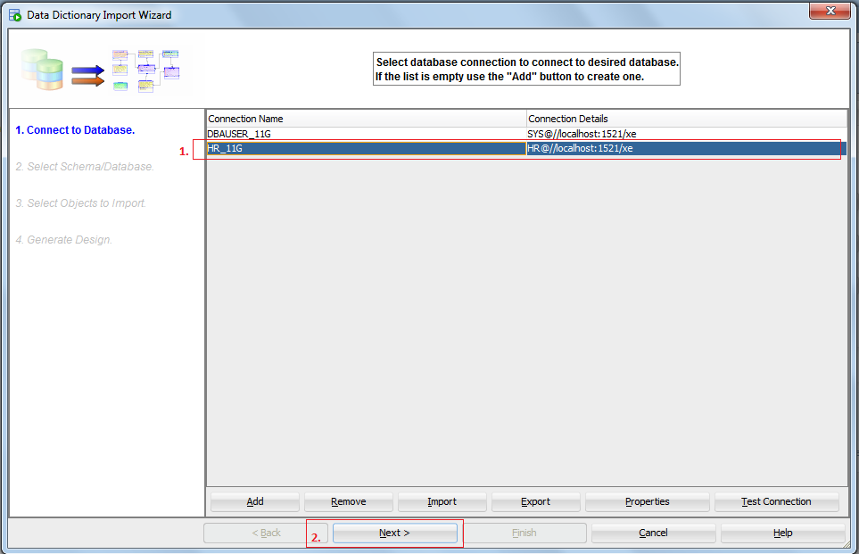

**Step 4:**

In the dialog box select the Proper 🡪 **“Schema name””** and Press 🡪 **“Next”.**

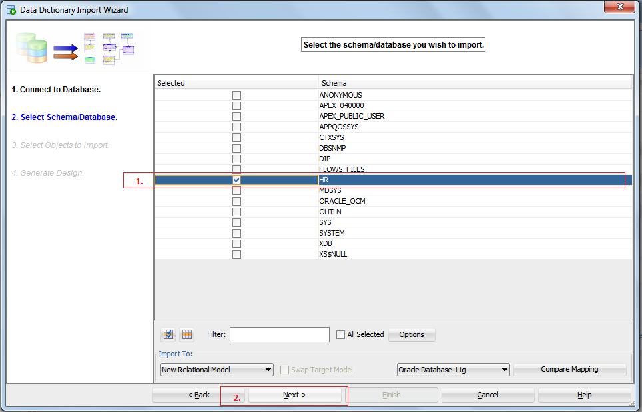

**Step 5:**

In the dialog box select the 🡪 **“Table names””** and Press 🡪 **“Next”.**

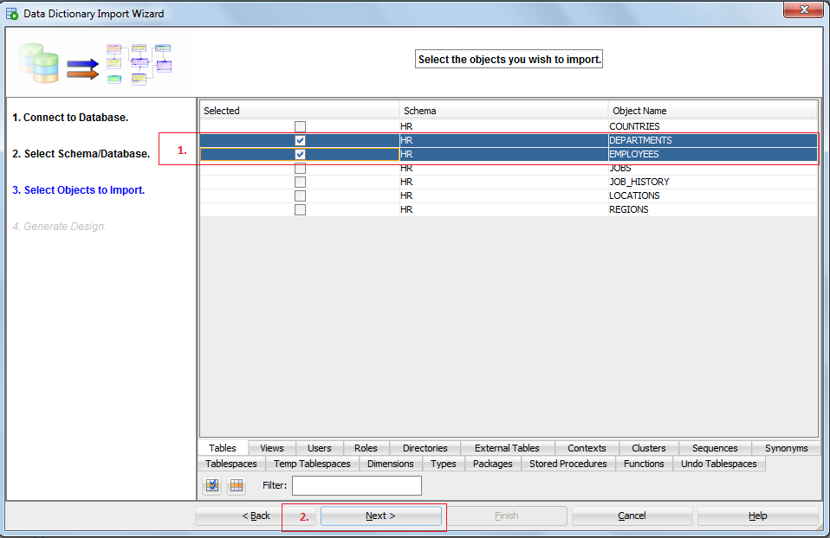

**Step 6:**

In the dialogue box just Press the **“Finish”** Button.

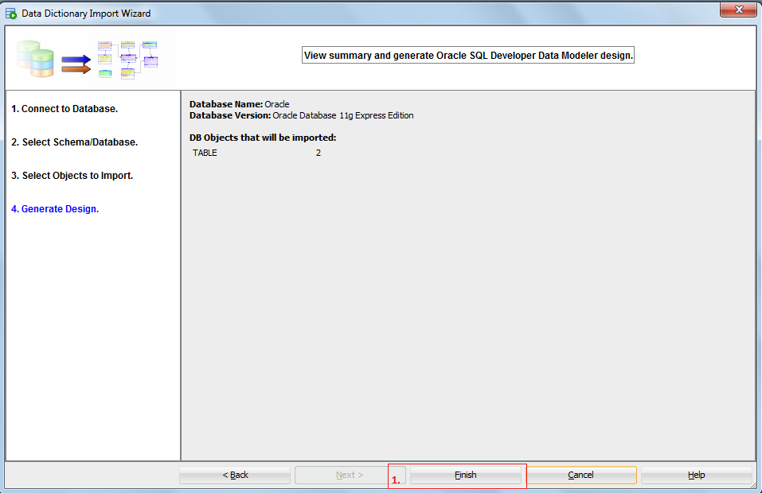

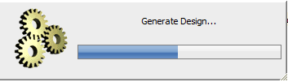

**Step 7:**

**ER Diagram View for the selected tables:**

* DEPARTMENTS
* EMPLOYEES

